**Config database:**

* Open hibernate.cfg.xml file to config to your server

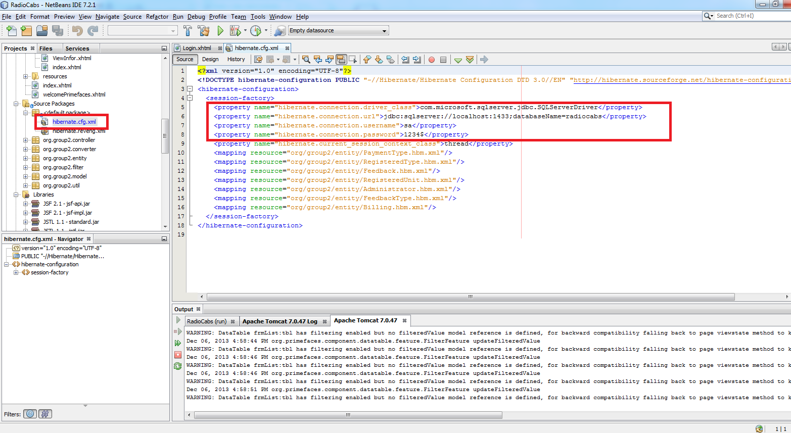

* Please start Admin page from Login page

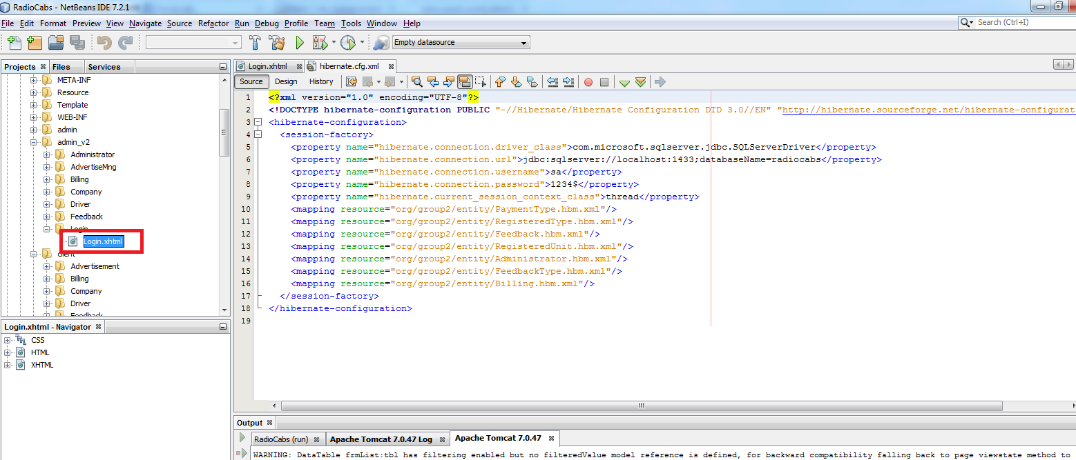

Admin

1. Login

* Enter admin email and password then Click Login button

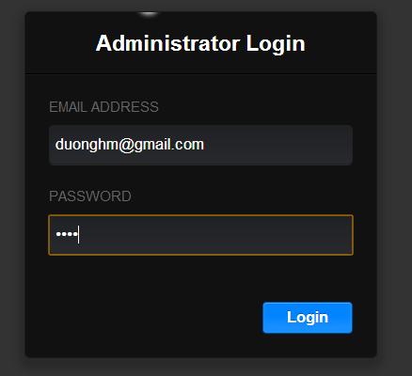

* Then you will see admin page

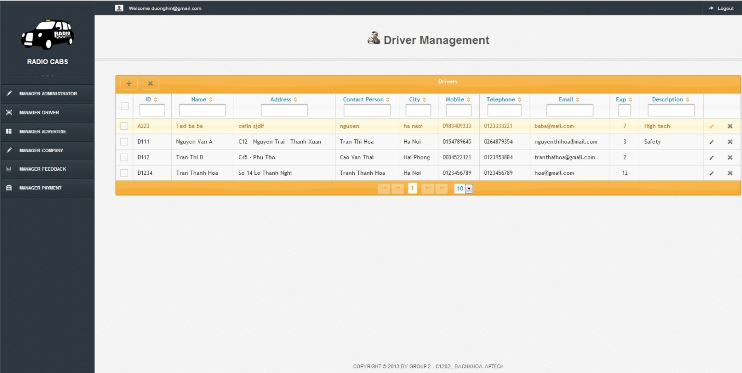

1. Logout

* Click the logout button

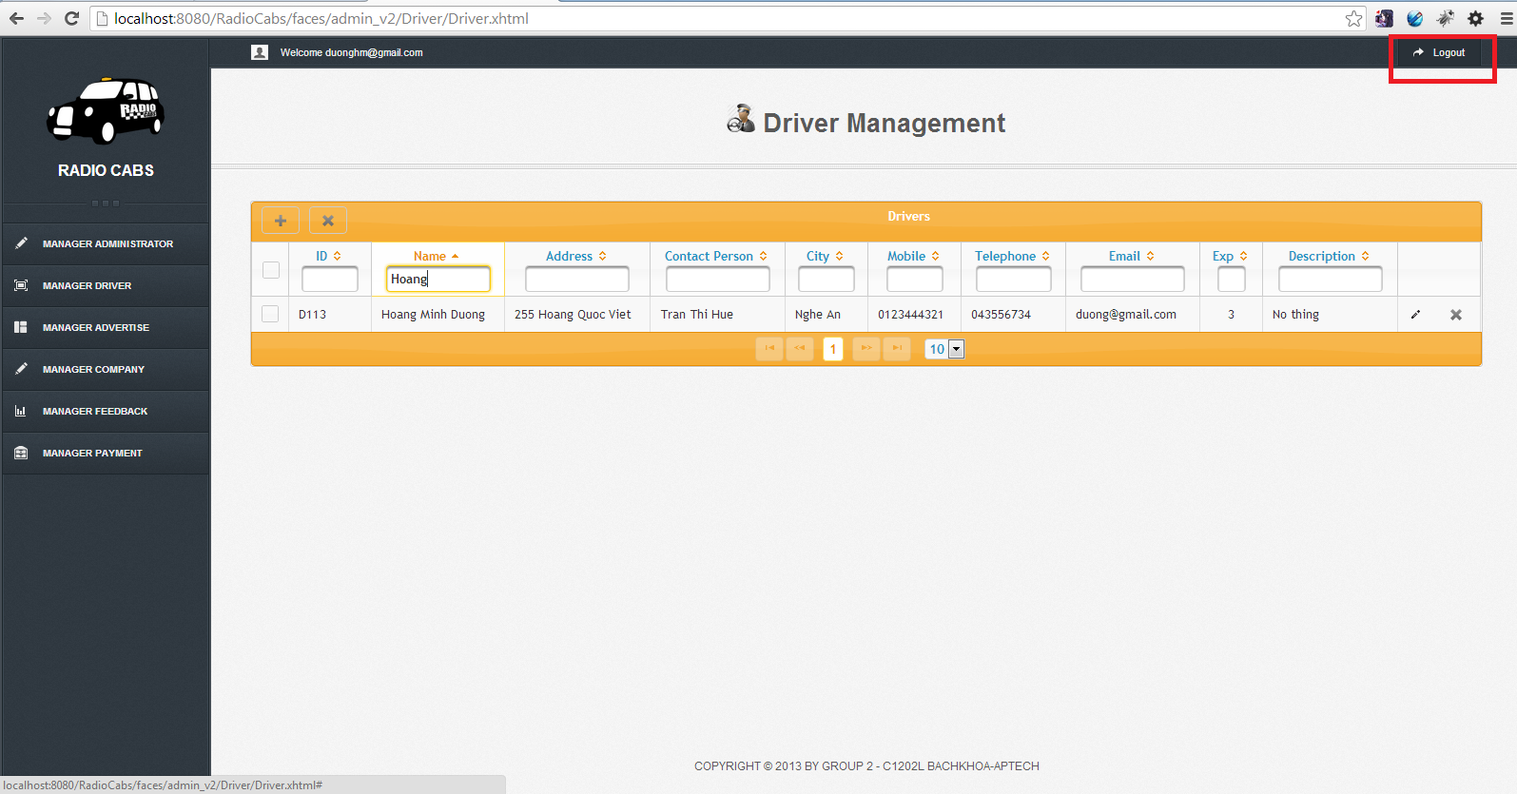

* Then you will go to the login page

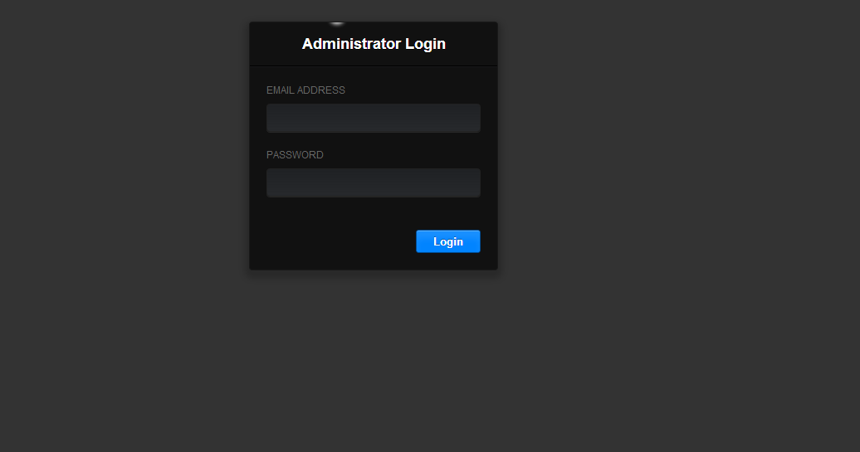

1. Create

* Click the Create button

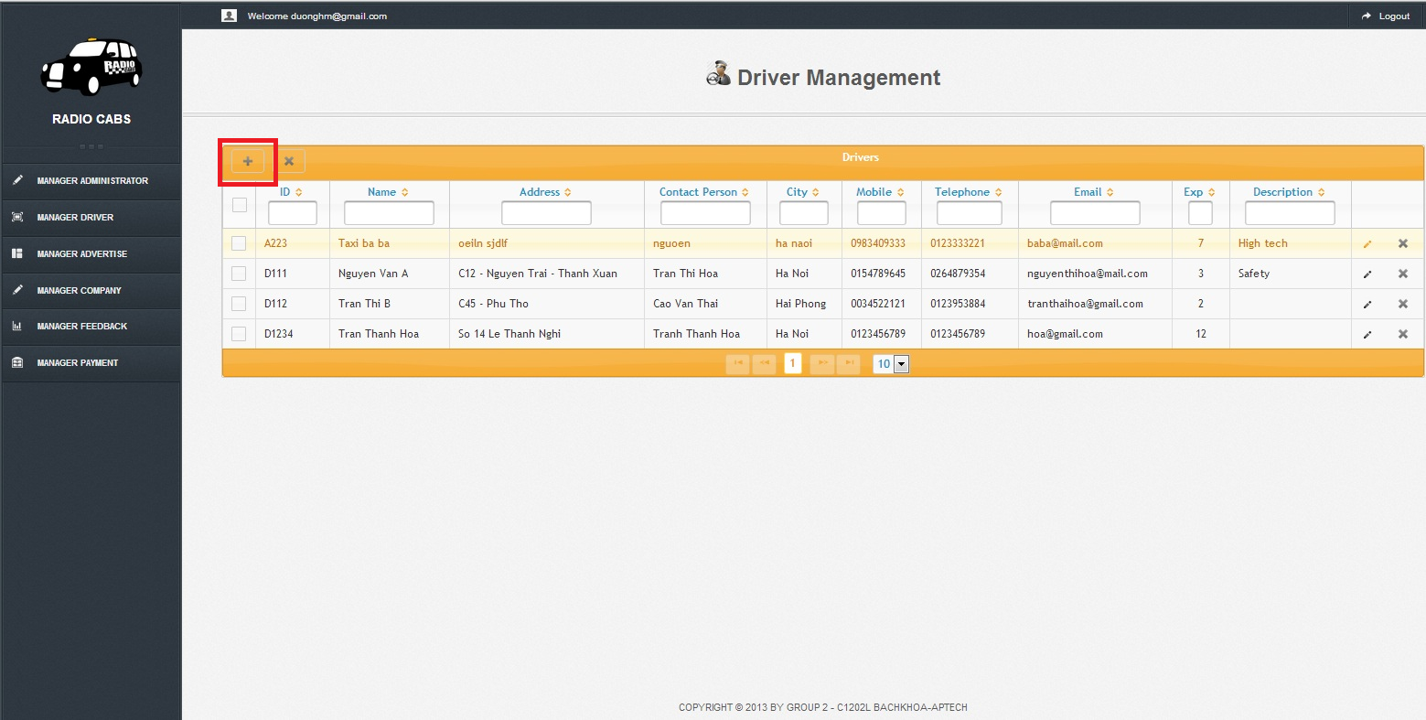

* Enter information in the dialog and click Create button

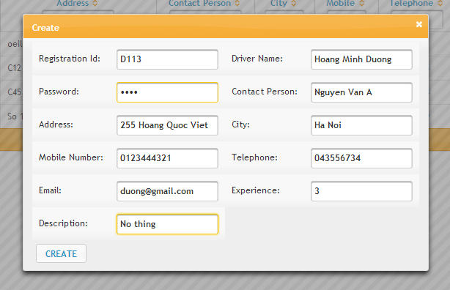

* Then you get the result likes this

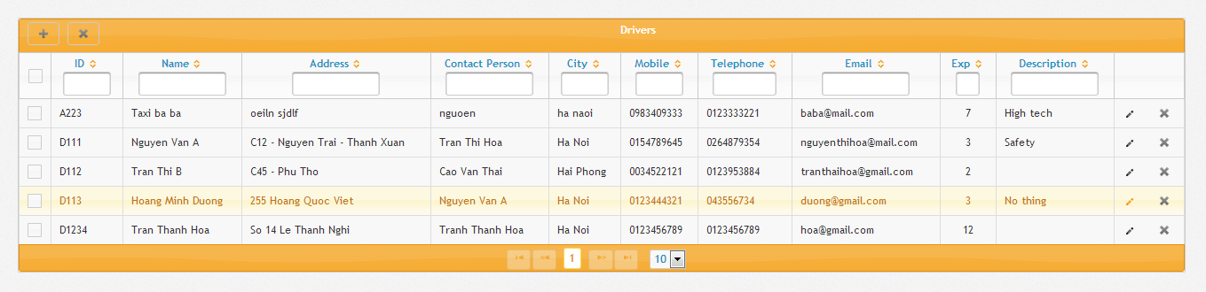

1. Update

* Click the edit button

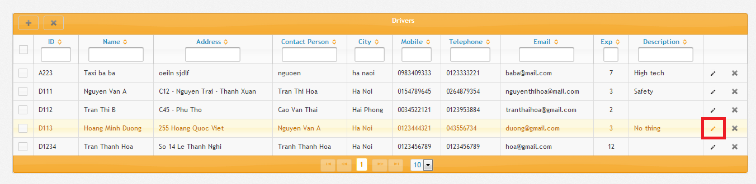

* Enter new information then click accept button

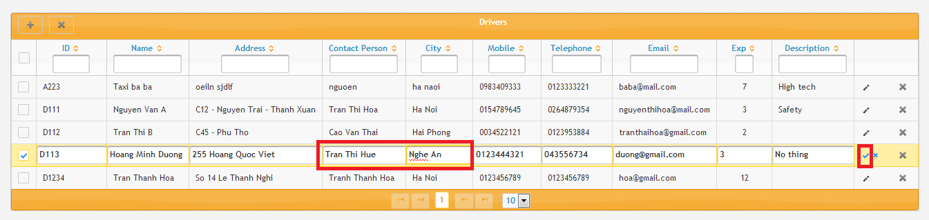

* Then you get the result like this

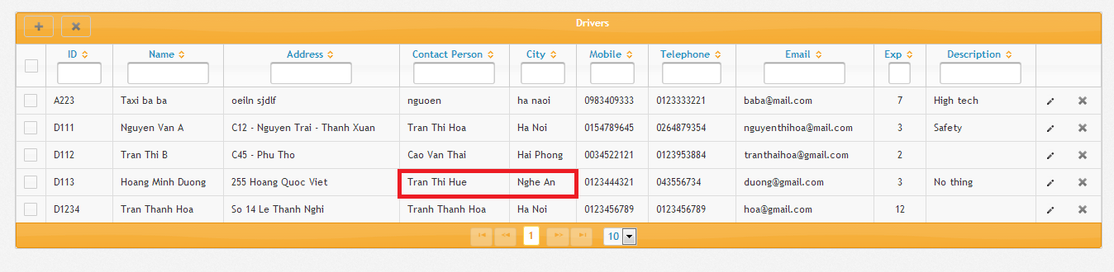

1. Delete

* Click the delete button

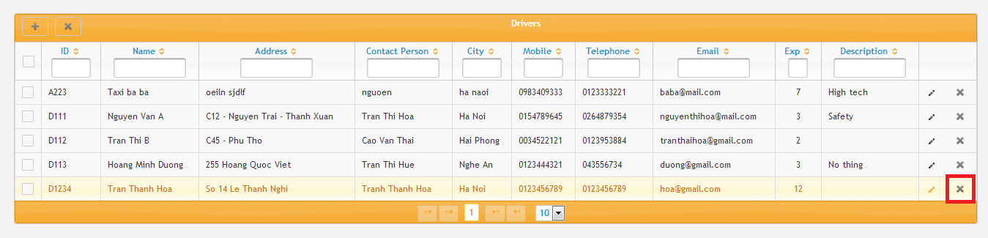

* Click Yes

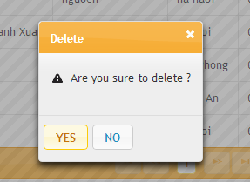

* Then you will get the result

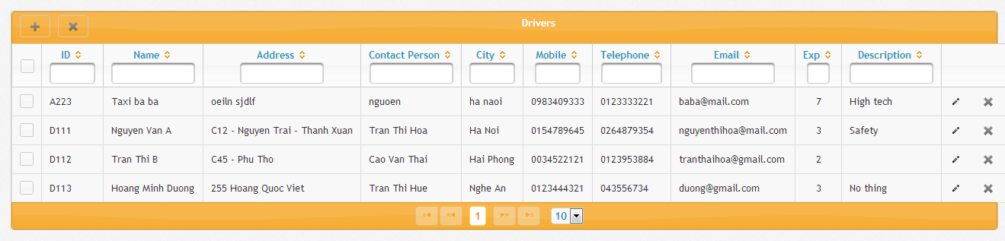

* Note : You can also delete many items by choose many item them click delete button on the top

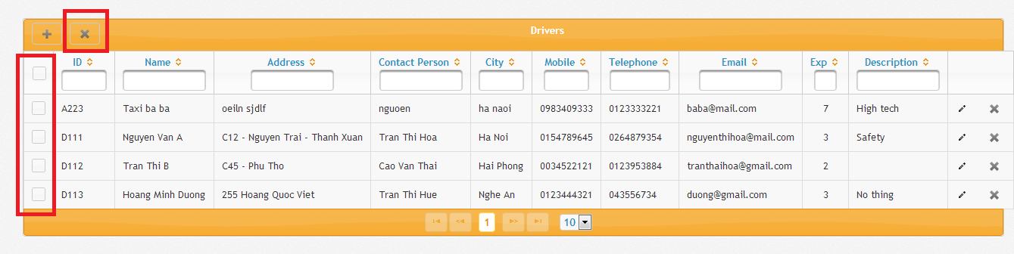

1. Sort

* Click on the column you want to sort by

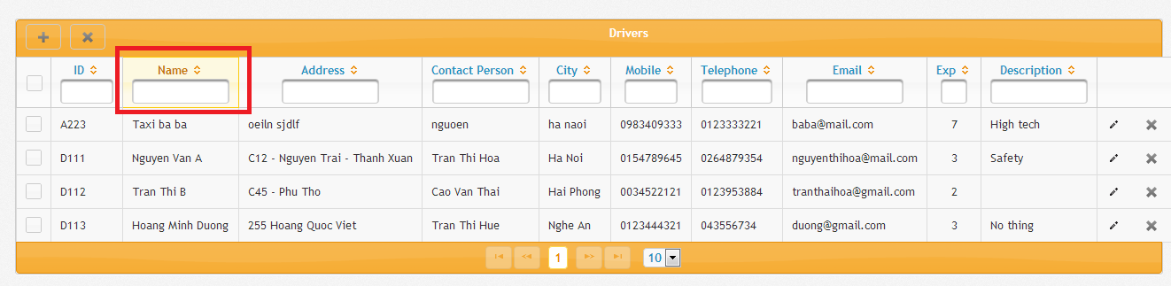

* Then you will get the result

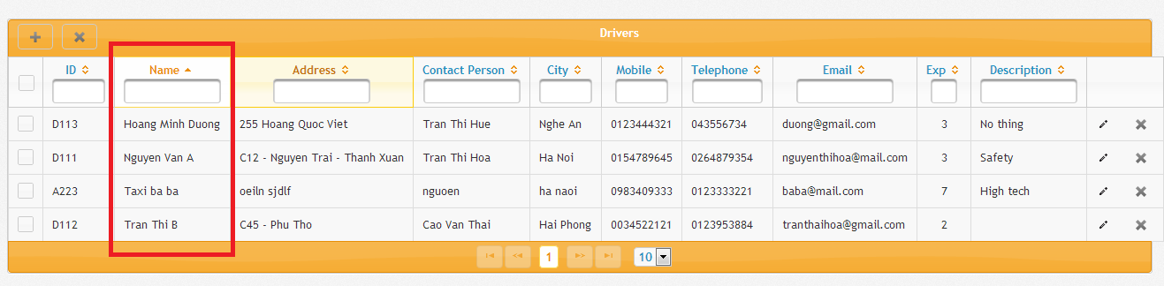

1. Search

* Enter the field you want to search

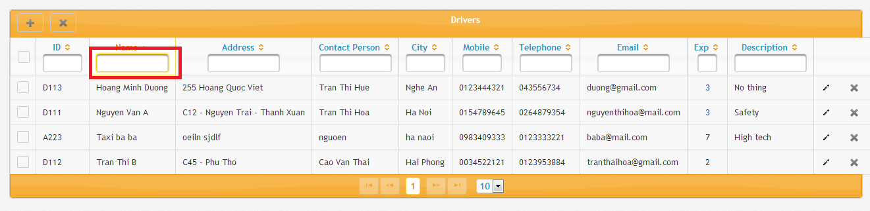

* Then you will get the result

